**Create the base features:**

1. What are the basic rules of the game?

Be the last player standing with health points. Players with 0 health points will be eliminated. The player that wins x rounds will be the winner of the match.

2. What is the objective for the game?  
Bring the enemy player(s) health points to zero by punching your appointment with punching glove, navigating with the plunger, and dodging with the dodge action. Players will use quick reaction and knowledge of the different interactions within the game to create advantages and become the last player standing at the end of the round,

3. What the style of online game is (Singler persistent server, lobby peer-to-peer, etc...)?

Players will enter a menu screen, join a lobby via LAN server, select their player to join , and then choose a map to fight on. This shares a lobby peer-to-peer style, and the lobby will not exist unless a player opens a LAN server. There may be multiple servers for multiple lobbies and games.

4. What are the choices available to the players to win the game?

Your primary means of movement are: Punch shot, Dodge, Plunge shot.

The player has basic run speed and jump as well. The player’s movement will be affected by being punched, plunged and dodging, with sharp movements and weighted punches.

Punching your opponent with punching glove will be the primary mean of winning. The player will have to use the plunger to traverse the map swiftly and have more elevated directions/ options of attack, the player can also perform a dodge action on the ground or air to avoid punch shots. The use of the three moves will operate as a rock, paper and scissors style gameplay which will help in the balancing factor.

5. What objects will you need?

A player object, punch shot, a plunge shot, and wall objects.

6. What objects must be created dynamically created?

The punch and plunge will both be dynamically created to perform a punch attack or a plunger shot.

**Create the board game:**

At the start of the game, every player will roll for initiative (player order), highest roll goes first, second highest goes second and so on. Once every player has completed there turn the *round* is complete. Once per turn, players can perform an action (Punch, plunge, or dodge). Each player starts with 3 health points. All roll actions will be performed with a d10 (ten sided dice)

*Each round is equivalent to a second in game time. Distance is the amount of tiles a player can travel in a single turn.*

On player’s turn following actions can be taken.:

1. **Movement:** Before picking an action you must follow any passive movements that apply to you (plunging or falling). Otherwise, you have the option to perform a pre-action movement.
   1. **Passive Movement:**If you are in the air and are not plunging, being plunged, or touching any surface then fall 2 spaces. If you had plunged to a wall/ground/ceiling and had not reached the wall/ground/ceiling yet move 7 spaces towards it.
   2. **PreAction Movement:** Before action if you are on the ground, you may run horizontally 2 tiles, jump diagonal, jump up.
2. **Action**:
   1. **Punch Attack**: You shoot your punch gun at opponent. If you hit the target loses 1 hp.
      1. Same Square: Auto hit.
      2. Neighboring square: Roll 3 or higher to hit.
      3. Within 7 squares: Roll 7 or higher to hit.
      4. Long range: Every 7 squares away roll 7 or higher on all rolls to hit.
   2. **Plunging**: Any wall, ground, or ceiling in line of sight you may plunge to. While plunging you are harder to hit, your aim is worse, and you move 7 tiles per turn until you reach your destination. All rolls to you and from you must be reduced by 2 while plunging. In the event that both the target and attacker are plunging, the attacker must roll a 10 to hit.
   3. **Plunge Attack**: You shoot a plunger at targeted player to draw them 7 spaces towards you and stun them for their next turn.(same range/roll rules apply as the punch attack).
      1. If you fail the roll you will be forced to perform a plunge towards the wall behind the targeted player.
      2. A stunned player basically loses a turn.
      3. If you are currently plunging and plunge attack, you are no longer plunging towards the previously targeted destination and will drop next 2 tiles or to the ground if only 1 tiles between you and the ground the start of the next turn.
   4. **Dodge**: Move 3 spaces any available direction. All attackers must roll a 10 to hit you.

Gameboard: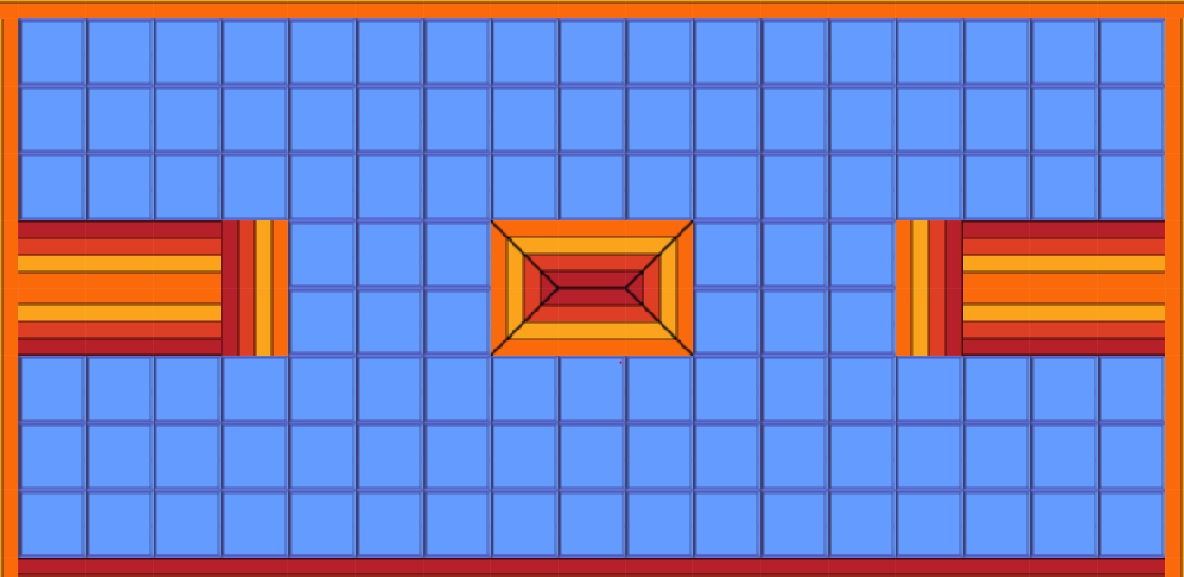Starting positions:

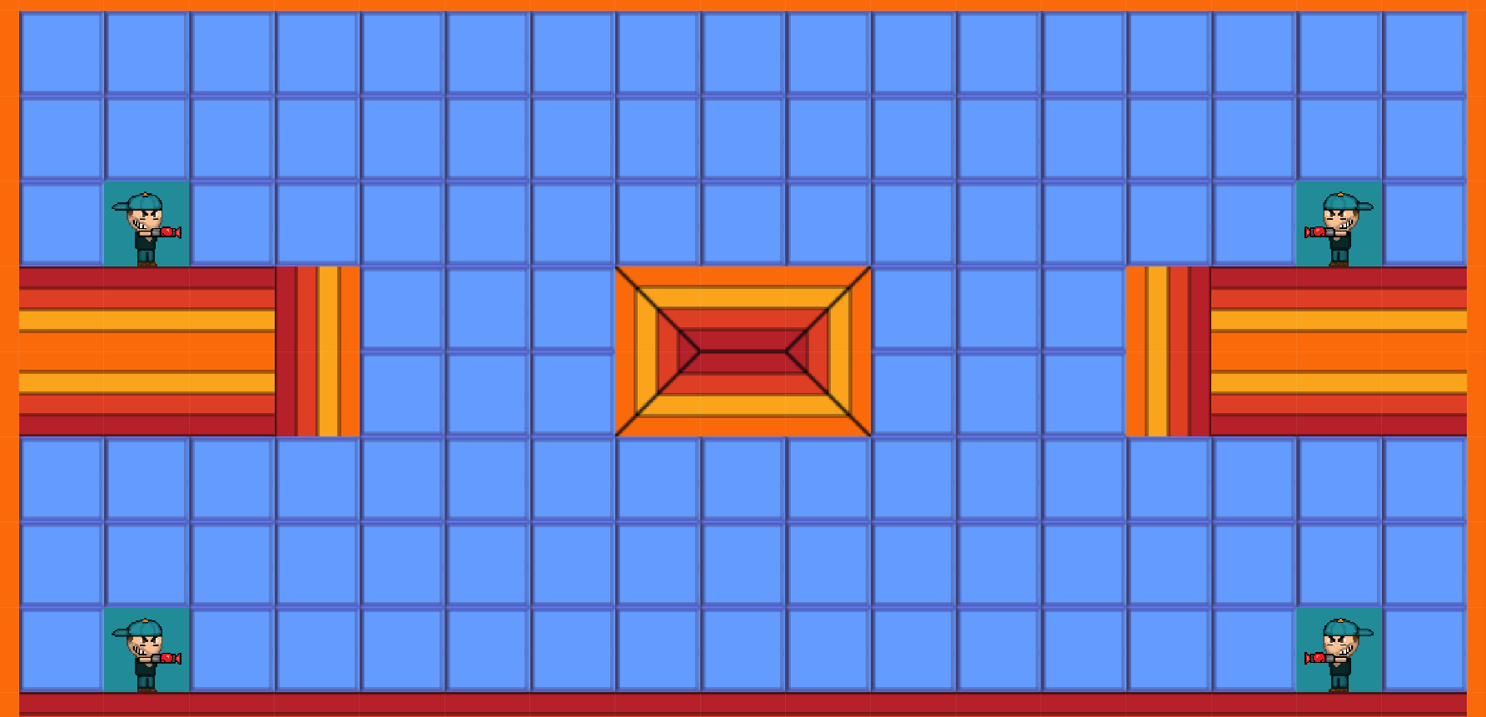

**Punch Attack**

* **Punch Attack**: Player must target a player to attack, and then roll a 7 or higher on a d10 for every 7 spaces away.
* **Close Range:** Opponent is in a neighboring tile (any direction) Roll a 3 or higher to hit.
  + **Roll Success:** the targeted player will lose 1 health point and get pushed 2 spaces in the direction of the punch.
  + **Roll Fail:**  your attack misses.
* **Point Blank :** The opponent is in the same tile, auto hit opponent gets flung back into wall of direction specified by attacker.

**Plunge Attack**

* **Plunge Attack:** Player must target a player to attack, and then roll a 7 or higher on a d10 for every 7 spaces away. If you are in the same tile you do not need to roll, the attack is an automatic hit. Strategy: Place yourself 7 spaces away from target to go for an auto hit with a wall fling.
* **Close Range:** Opponent is in a neighboring tile (any direction) Roll a 3 or higher to hit.
  + **If all rolls are successful:** the targeted player will become stunned for a single turn and move 7 spaces towards attacker.
  + **If you miss any rolls:** Your attack goes through your target and hits the wall behind. Attacker is now 7 spaces towards the wall.
* **Point blank range:** Although you have the choice to to auto hit you can opt to hit the player with your plunger and fling. You are in the same tile, you do not need to roll, the attack is an automatic hit. Choose a direction in which to fling the player 7 spaces.

**Plunge Wall/Ground**: Move to any space within sight of the current square. However, you can only move 7 squares per turn. Plunging will take a turn but you will be able to gain the most distance. If it’s your turn again and your last turn you are still plunging you can attack while plunging. Any players attacking you **mid flight** must roll a 9 or 10 to hit you. Likewise, you must roll a 9 or a 10 if you are attacking mid flight.

Moving spaces: Moving spaces is represented by the amount of lines you pass through. A corner counts as single line pass. The nature of counting spaces can be seen in the picture below.

**Mid-flight status: You are currently mid flight until you have reached your destination.**

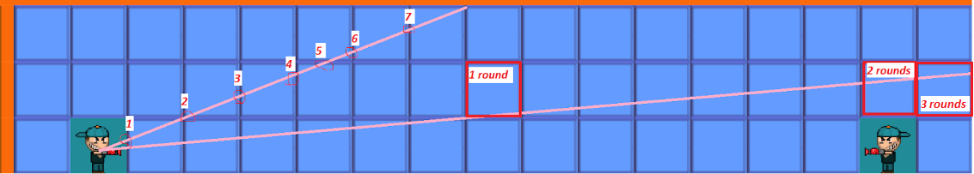

Long Range Movement: The boxes titled round represent where you’ll be at each consecutive turn.

Example: Round 1 you aim to hit a far away fall(above right players head).By the end of your first turn you reach the “1 round” box (you are now **midflight**). Round 2 At the **start** of your turn automatically move to the 2nd square and then perform an next action (you are still midflight)**.** Round 3 At the start of your turn automatically move to the “3 rounds” square since there is no more tiles to traverse. You may then perform your next action(you are no longer mid flight)**.**

**Dodge**

* **Air Dodge** : *You perform a small dash going into any desired direction.* 
  + Any player targeting you must reduce their attacker roll by 3 and player moves 3 squares.

**Preaction Movement:**

For this game the movement style is roughly based off of the tabletop RPG Dungeons and Dragons combat movement system, wherein you have the option to move an before performing an action.

**The following shows the movement a player can take before performing an action.**

**A. Ground Movement**

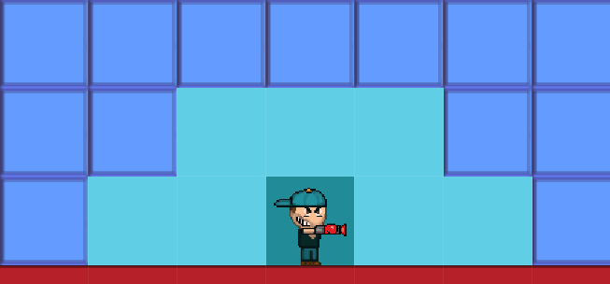

In example **A** the player can jump up or diagonal, or run horizontal 2 spaces, and then perform an action.

**B. Off the ledge**

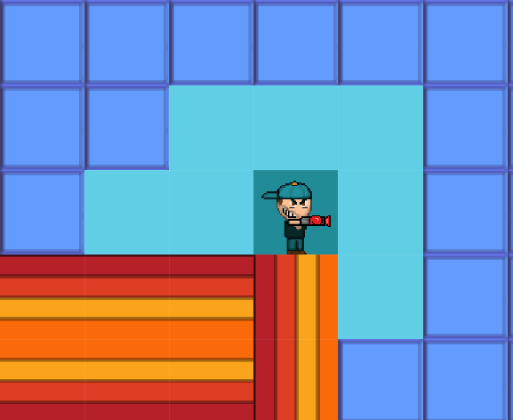

In example **B**  the player can run of the edge and then perform an action.

**C. Falling**

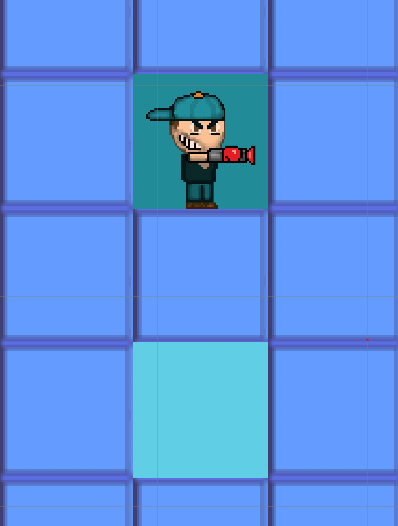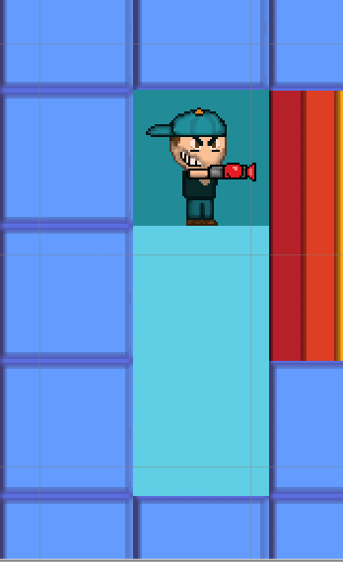

In example **C** any player not midair, plunging, nor attached to anything **MUST** fall 2 squares, however, if a wall is adjacent the player can opt to fall a 0,1, or 2 squares then perform an action.

**D.Ceiling fall.**

Upon being attached the ceiling at the start of your turn you may choose to fall downwards 2 spaces.

*Side note :Each turn is equivalent to a second in game time. Distance is the amount of tiles a player can travel in a single turn.*

2. Play the board game and write a 2 paragraph essay about any modifications to the game.

After playing a rousing round of punch and plunge we quickly discovered that plunging needed to be reworked. At first the plunger would bring in the enemy for an auto hit, which sounded fun until we discovered that when both players are close quarters, the two will ultimately hit each other until death and have no other reason to move around until the game is over for the both of them. The solution to this “forever close quarters” issue was to separate the players post combat by adding knockback from the punches. After all, a punch is a repelling force much like the plunger is a pulling force. Being able to control where a player lands seems like a higher reward in return of the higher risk of possibly plunging right towards the enemy.

On top of that, hitting the opponent out of range after a successful punch works as a unique way of respawning the hit player out of direct range of attack while simultaneously fitting neatly into the logic and design of Punch and Plunge. Having a player die and then reappear post mortem after a wallop doesn’t make sense, as opposed to simply flinging the player out of reach of the attacker.

3. Discuss what went well, what didn't, and any concerns that were brought up for the game.

The game itself feels fun and has received plenty of positive feedback. The mixture of chance and strategy is completely apparent via having to roll for hits and maneuver with the plunger in and out of range of the opponent(s). For instance, veteran players can maneuver the gameboard to stack the odds in their favor however, it’s *still* possible for them to roll 1 out of 10 on every hit they try to land. Alternatively, a novice player can have no strategy and pull off long range snipes by complete chance! As of this point this game shouldn’t be too hard to translate into a real time game. The lack of use from the dodge move is apparent in a 1v1 setting. But within multiplayer matches the have greater than 2 players, we predict it will be used more often to take the heat off certain targeted/ low health players.

**Write the initial feature set:**

1 Using the core rules and the modifications made from the board game write a list of basic features for the game you wish to create.

A punching force that occurs when a player gets damaged from another punch object.

A player will be able to “grapple” to the wall objects with the plunger.

A player will be able to dash on a cooldown in a specific direction

A player will be able to move left and right on the ground and in the air(with some lockout of in air movement in certain scenarios).

A player will be able to jump and be affected by gravity.

Wish list:

Interactions between punch objects and plunge objects.

Interactions between 2 punch objects.

Interactions between 2 plunge objects.

Interactions between 2 players dashing into each other.